Hi Dave,

Below are the findings regarding **“Uploading multiple documents into Plunket’s Accident Intake portal”.**There are two methods by which we can enable the user to upload the multiple documents against accident information in advance form.

**Method 1**:

We can add more than one upload buttons in advance form while we are **creating** accident record.

User will upload the documents and will see uploaded document **name only**, see below screenshot. On each document upload we will save into SharePoint.

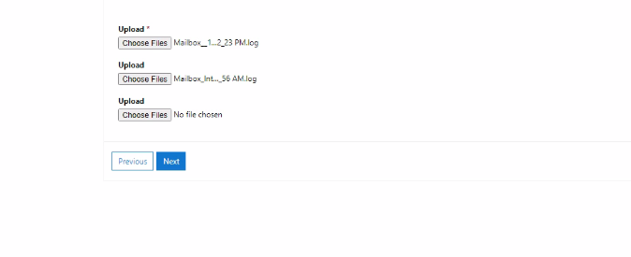

**Method 2**:  
If user is required to preview the uploaded document/snip, then he can only **upload one document** while creating accident record. He can add **other documents/snip** when user will edit the record like in below image.

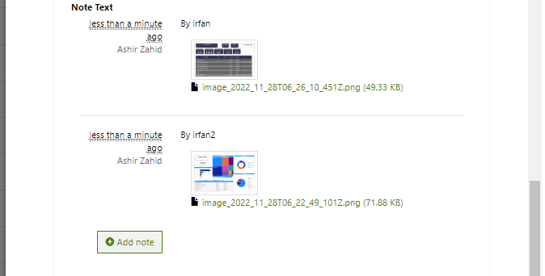

By clicking the **add note** button he can add required images and can preview images too.   
But to achieve this, we need to show all of the already existing records into **CRM view form,** all or desired record once enlist (using CRM views) then user can navigate to edit any particular record, there user will see record all entered data as well already saved images, plus he can add other images.

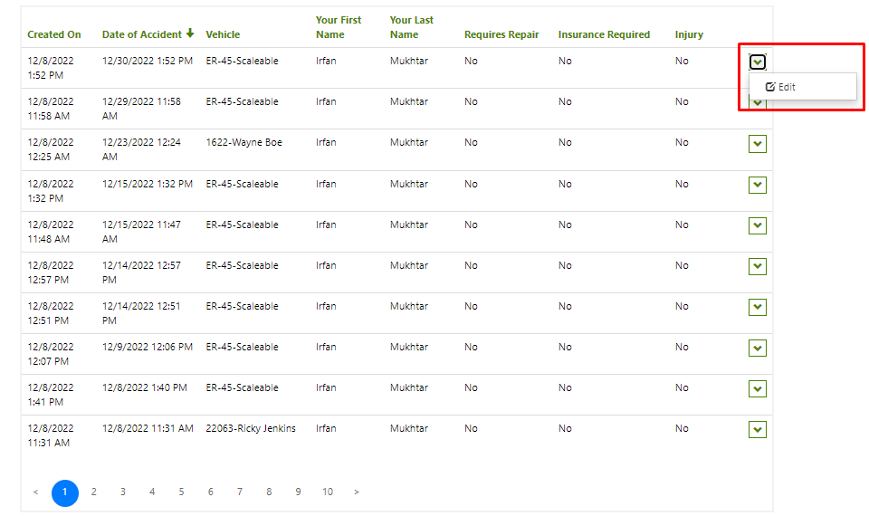

This is how all or filtered accident records will show into list and user once click on edit then he can add other snips. Thanks